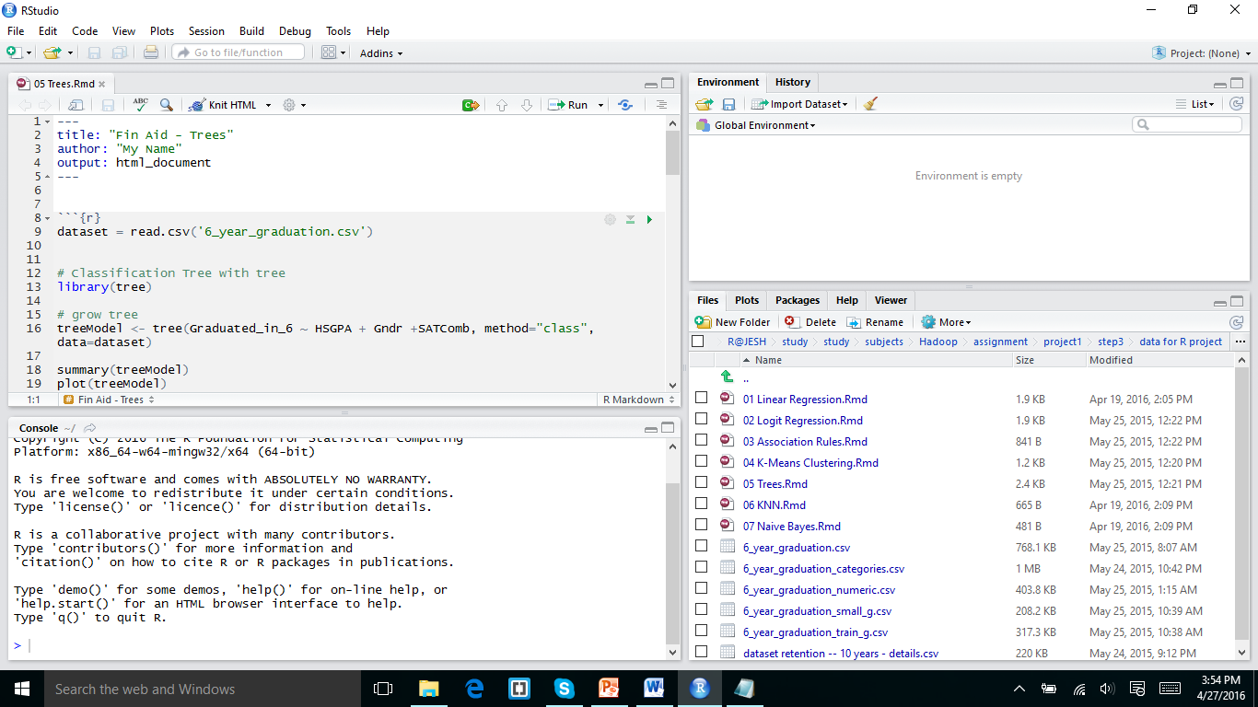

I installed the R and Rstudio and I downloaded the data for R project from the web campus and downloaded it and keep it as the home folder for R studio Now I downloaded the specific Rmd script from folder and for my id it is 05 Trees.Rmd

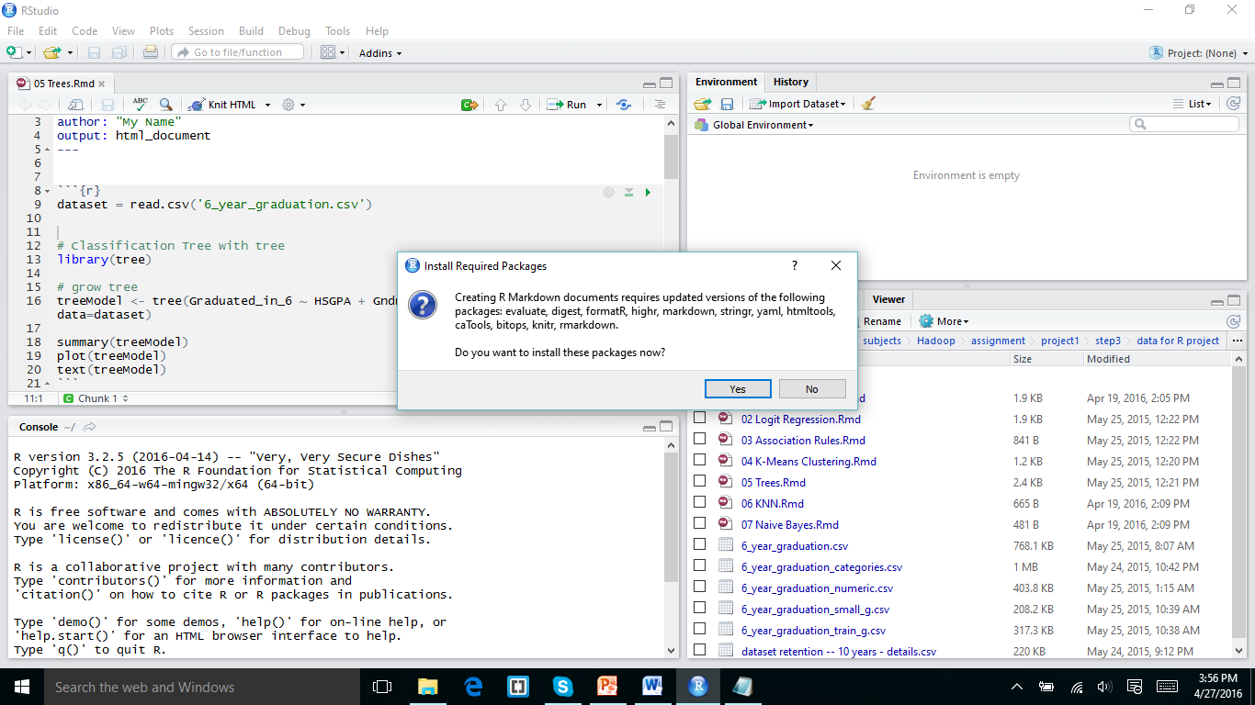

In the Above slide show what packages I installed evaluate digest formatR and highr markdown and stringr.

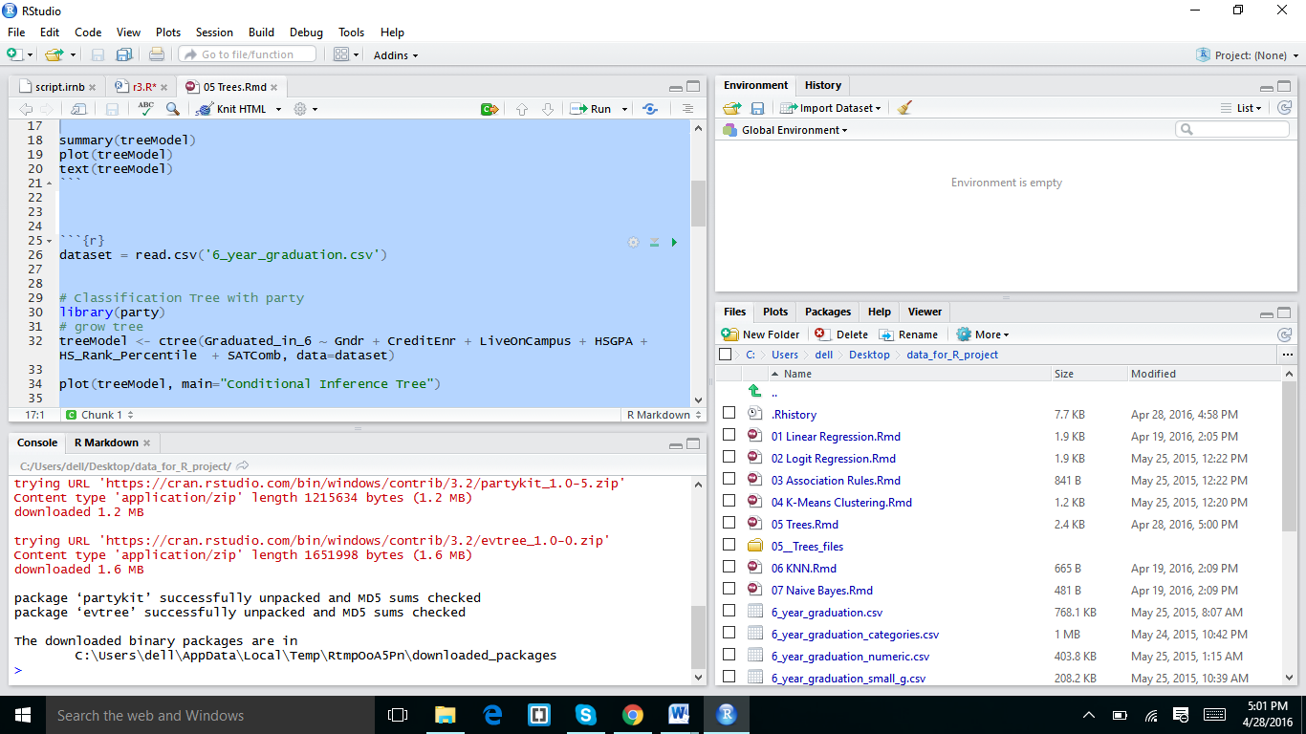

In the above screen shot I used some other packages and I successfully run it

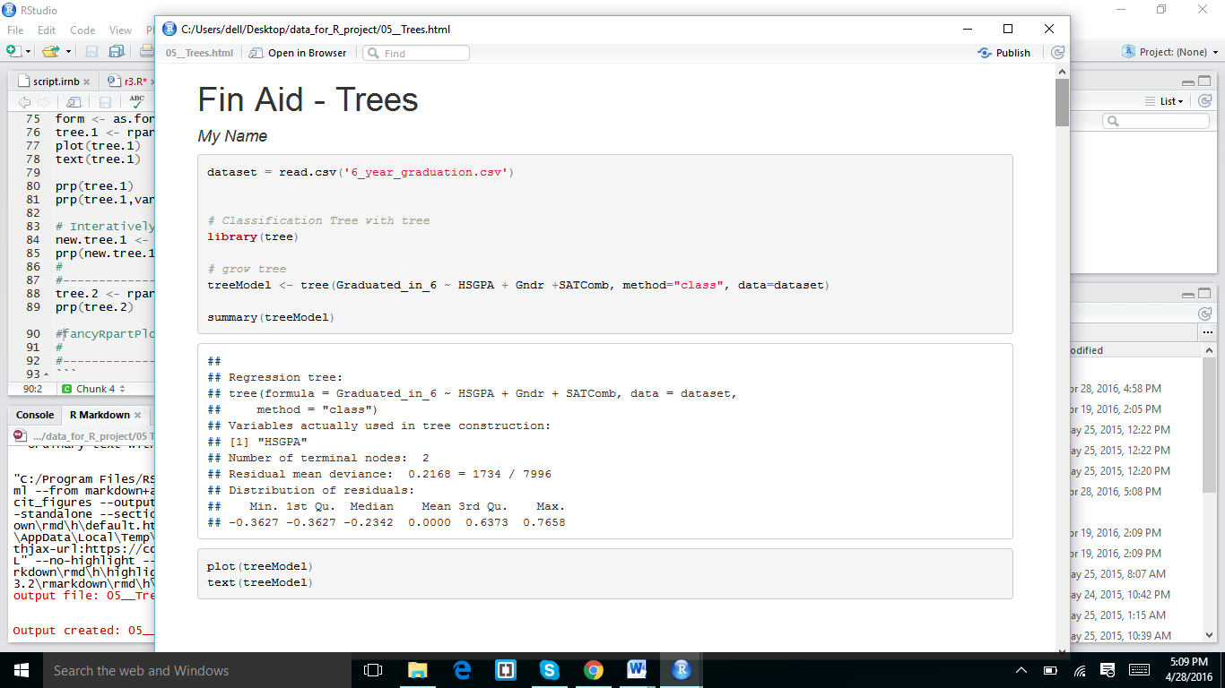

And I got the out put as shown in the screen shots

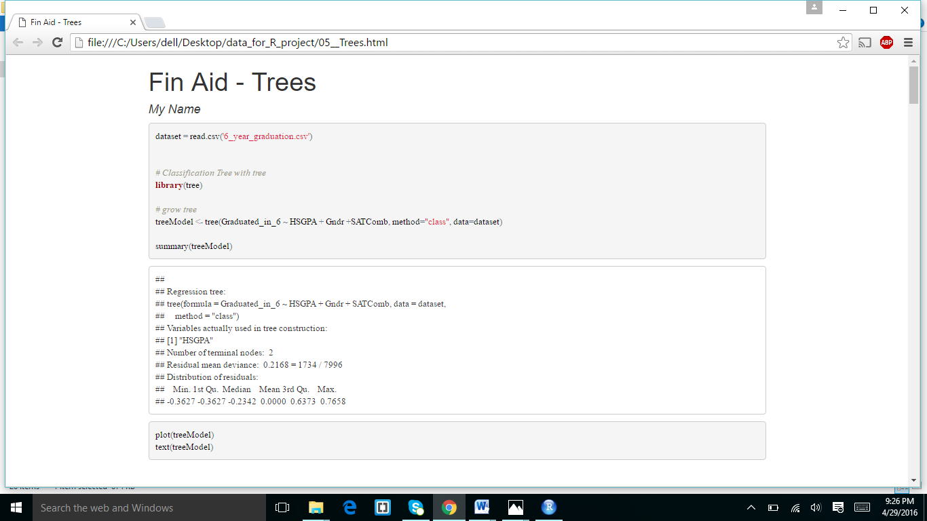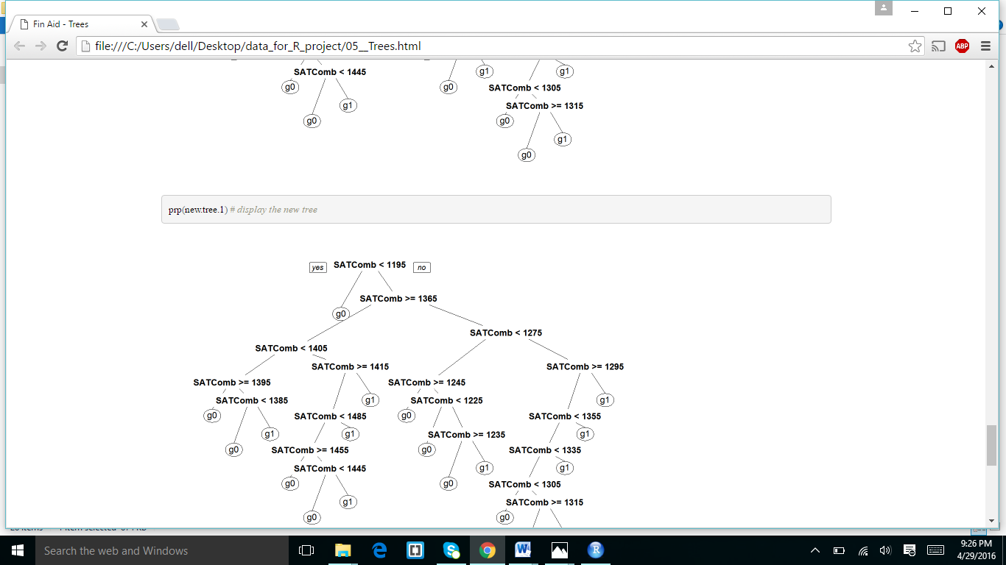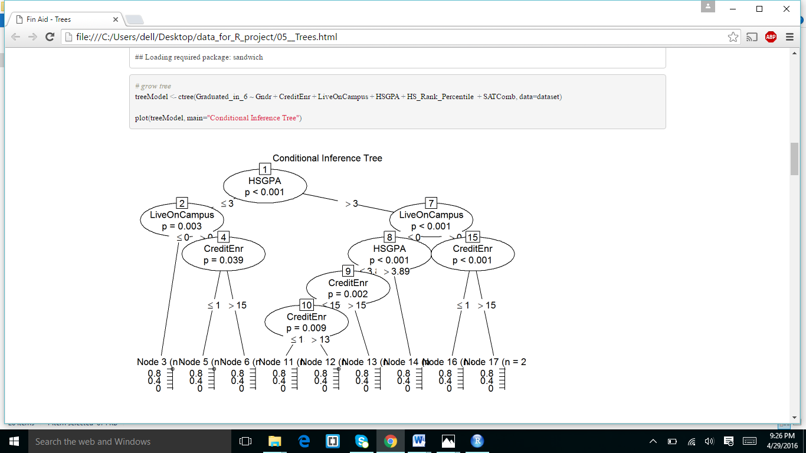

**ANSERS FOR THE QUESTION NO 8:**

* Decision trees datamining method.
* Un supervised method.
* Data Set which my script used is:6_year_graduation.csv file
* I installed evaluate digest formatR and highr markdown and stringr packages.
* Tree library.

**EXTRA CREDIT ASSIGNMENT2 :**

I sign up for the kaggle .com and I downloaded the script from the given

I downloaded the R script from given Link and I kept the script in the home location and I RUN the script.I got the below results in pdf form

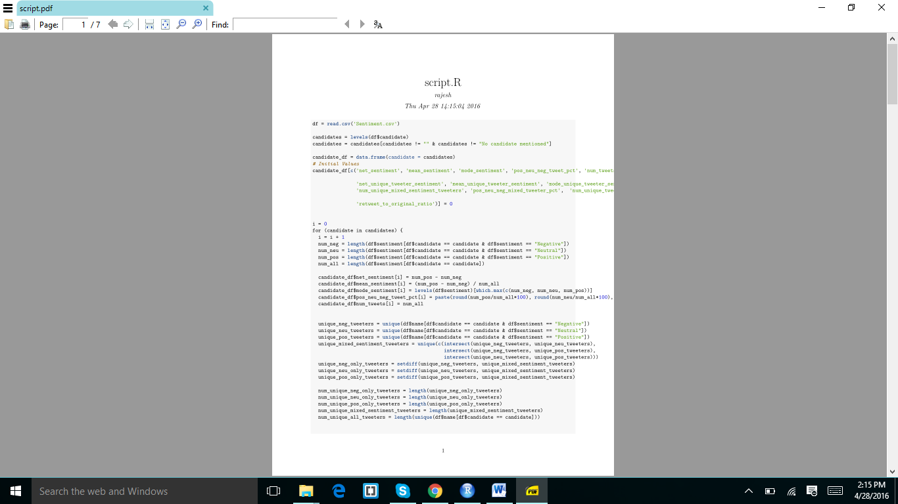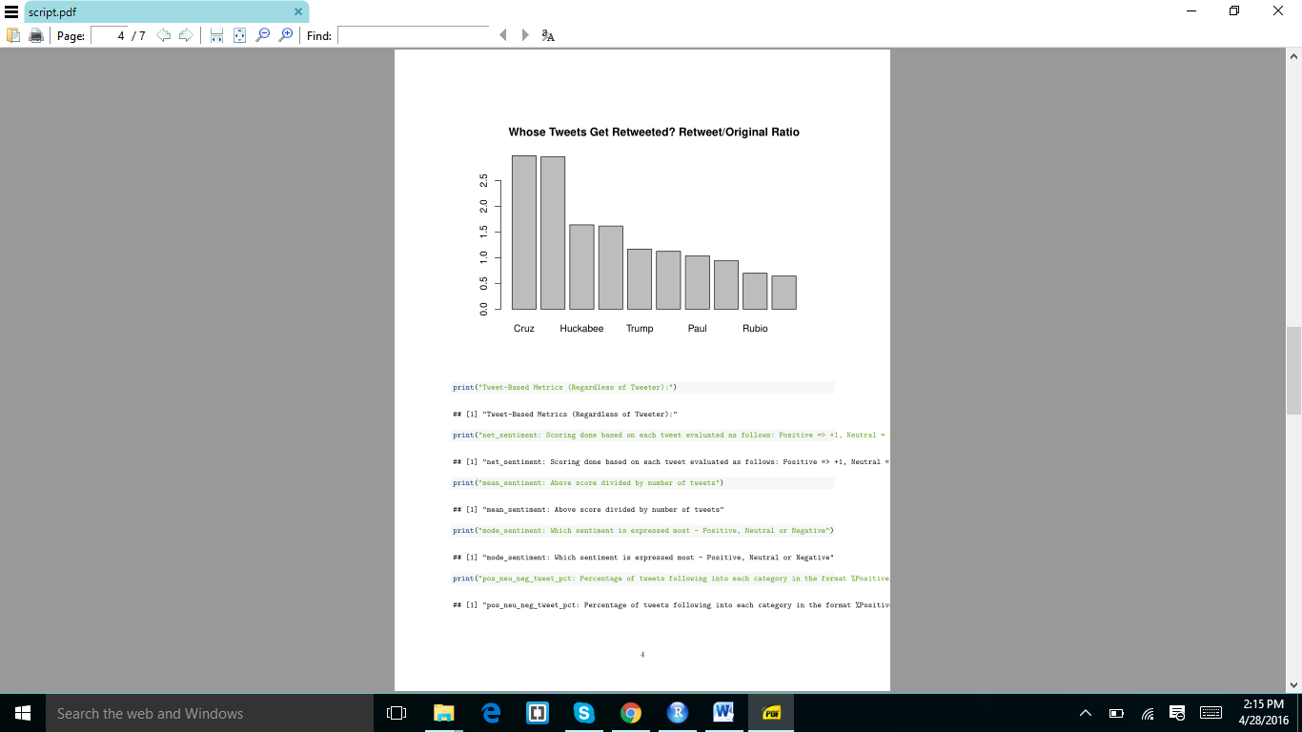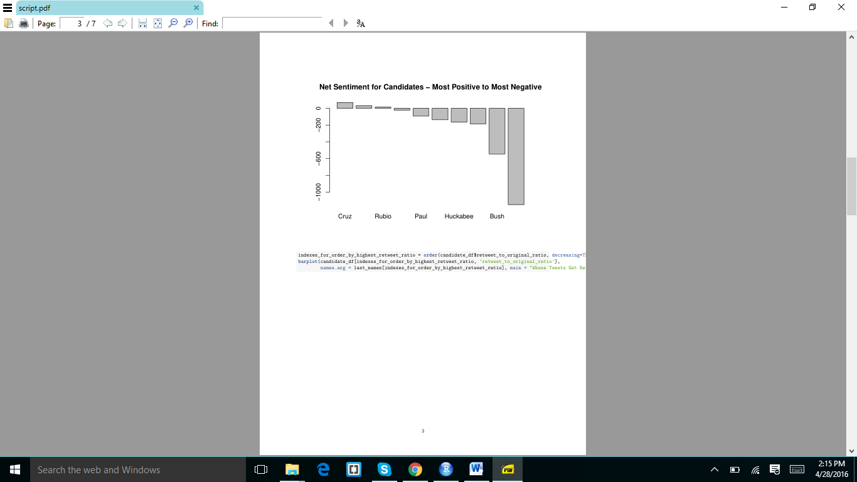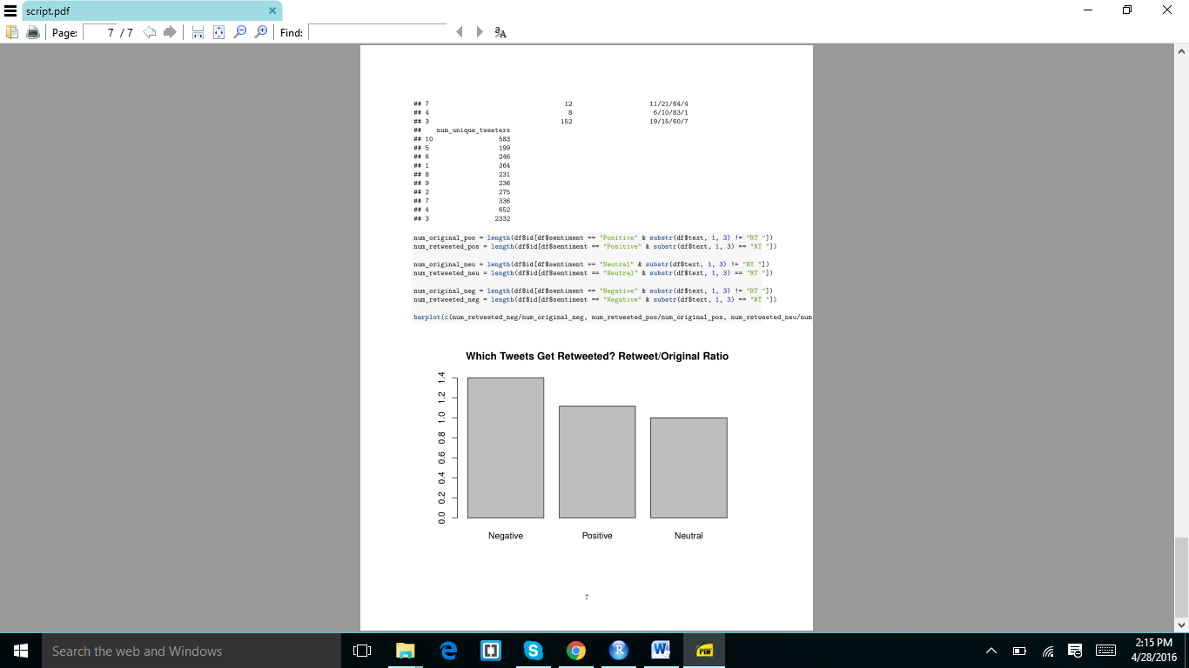

I got the results in pdf because I downloaded and install theMiktex

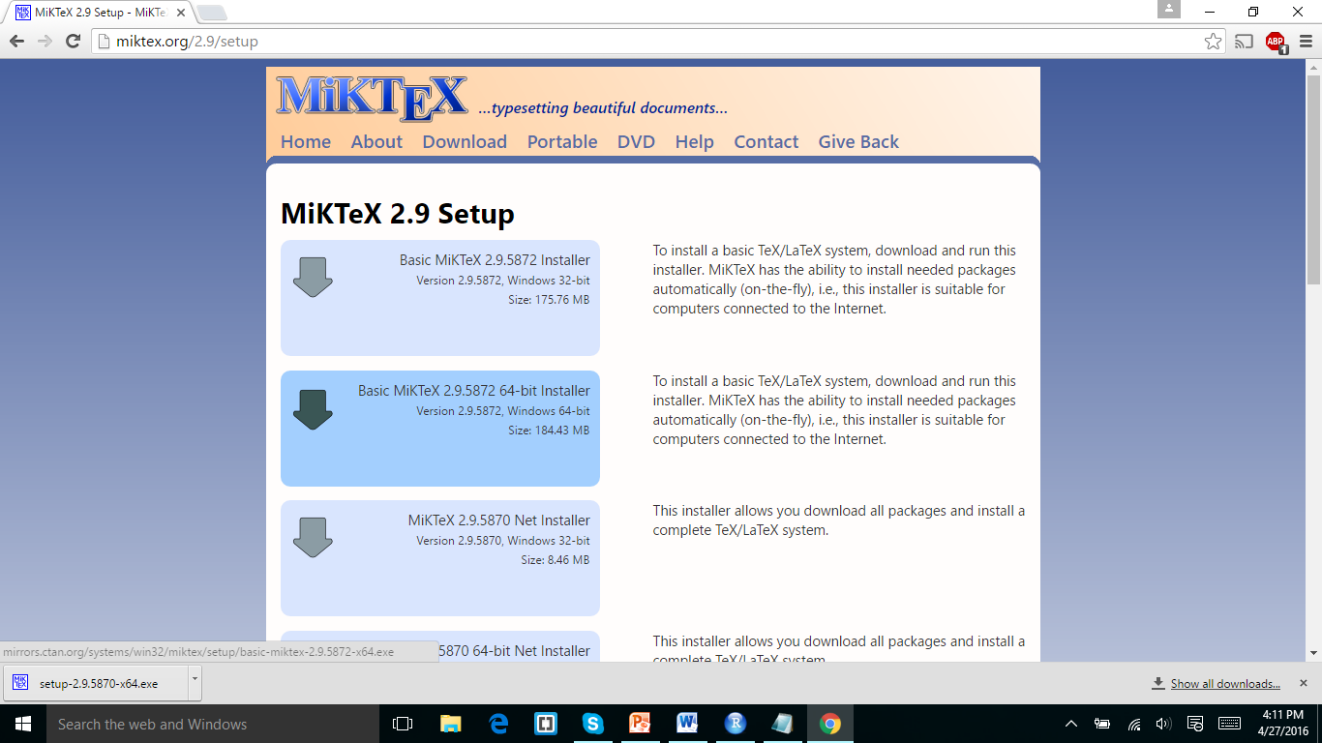

**ASSIGNMENT 3 EXTRA CREDIT:**

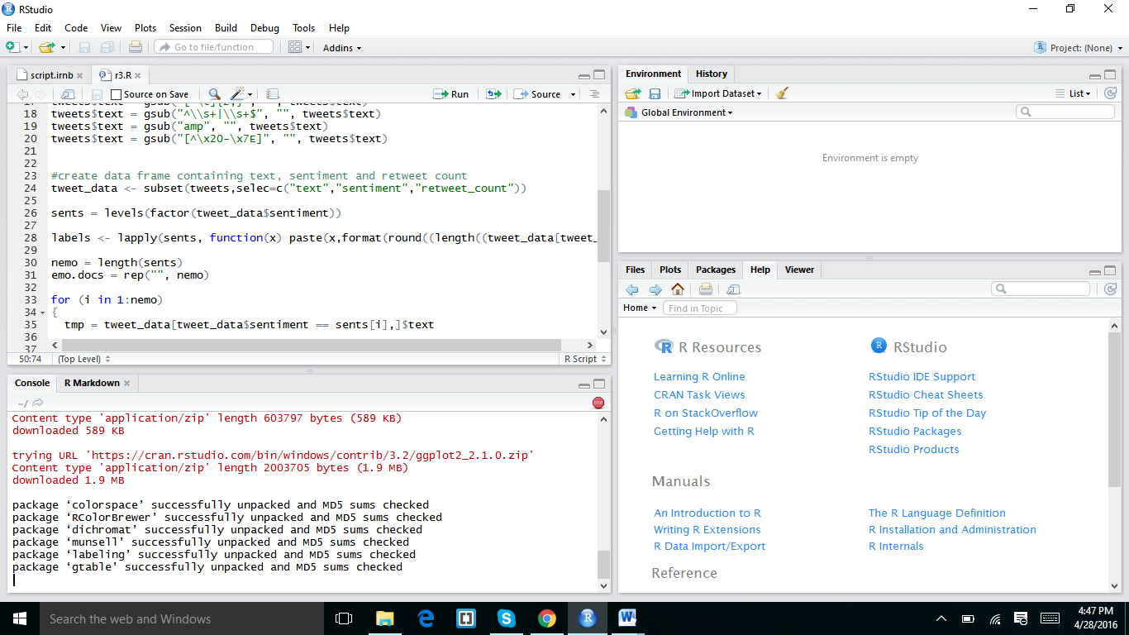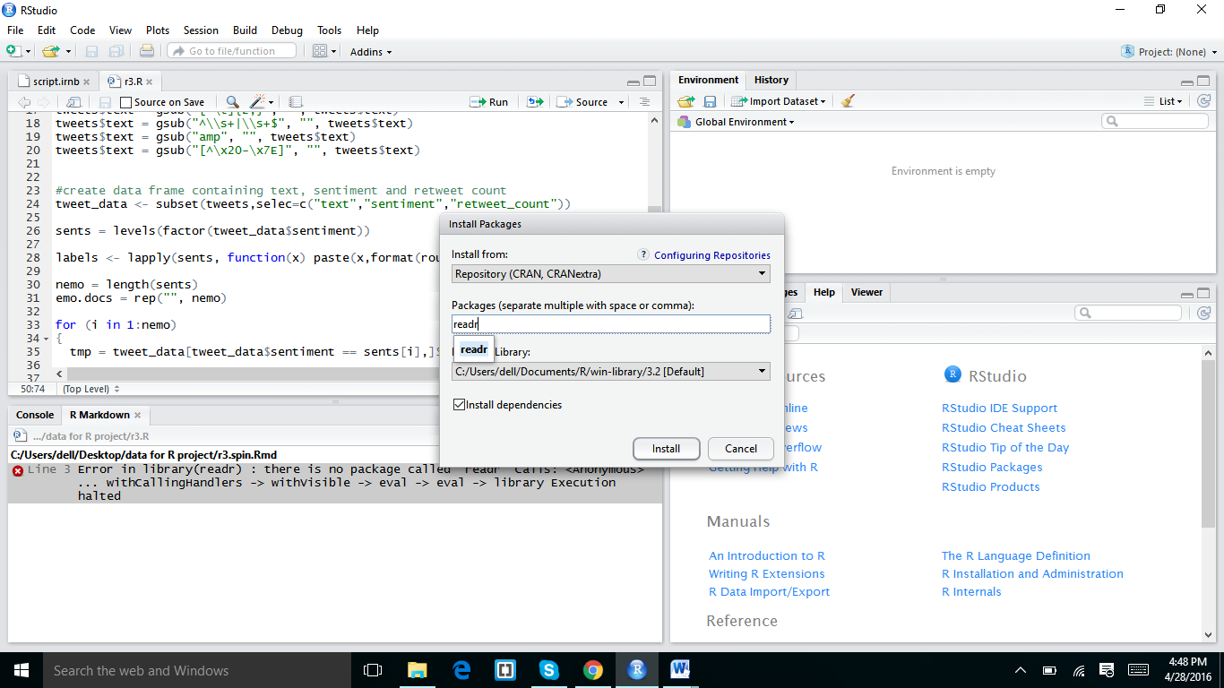

In the above screen shot I downloaded the readr package and I installed some more packages in below screen shot



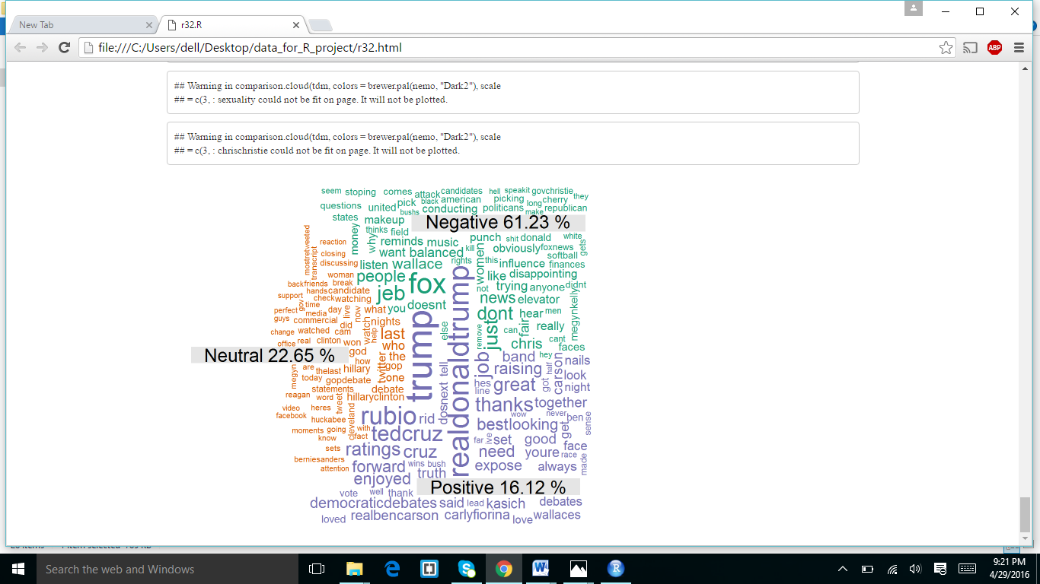

I got the above out put.